Wordly User Manual for Microsoft Teams Meetings
Prepared by ZoeChiu@evershinecpa.com Dated 20260320
to set up and enable the Wordly instant translation service in Microsoft Teams meetings :
A. Basic Conference Information
in Teams , please confirm the following information and inform all participants in advance.
- The main language expected to be used in the conference (speaker's language) (Maximum 8 languages)
- Teams meeting time slot (Taipei time)
- Teams Meeting Link
- Teams Meeting (English Name)

B. Pre-meeting preparation: Log in to Wordly and set up a session.
To ensure the smooth running of the meeting, the meeting host or administrator must complete the following settings before the meeting begins .
Step 1: Log in to Wordly (You can log in to your account and open different sessions to use the translation system simultaneously)
- Visit the official Wordly website: https://portal.wordly.ai/ (It is recommended to bookmark this page)
- Ask Zoe Chiu (邱莉婷) to get Yonghui's account (Email) and password.
- Enter your Yonghui account and password to log in.
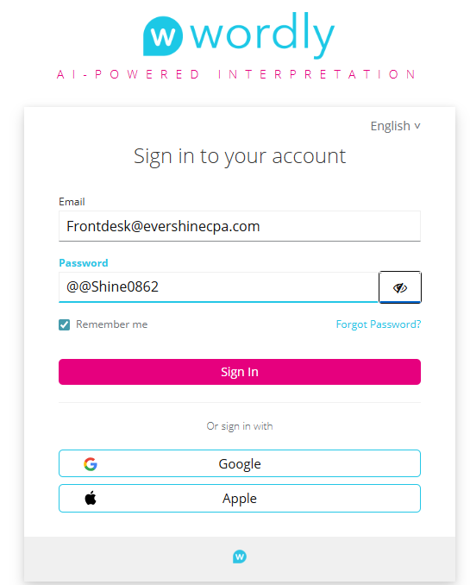
Step 2: Create a new translation session.
- After logging in, click "Session" on the left side of the page .
- Tap “ + Add Session” in the upper right corner to start creating a new translation session.
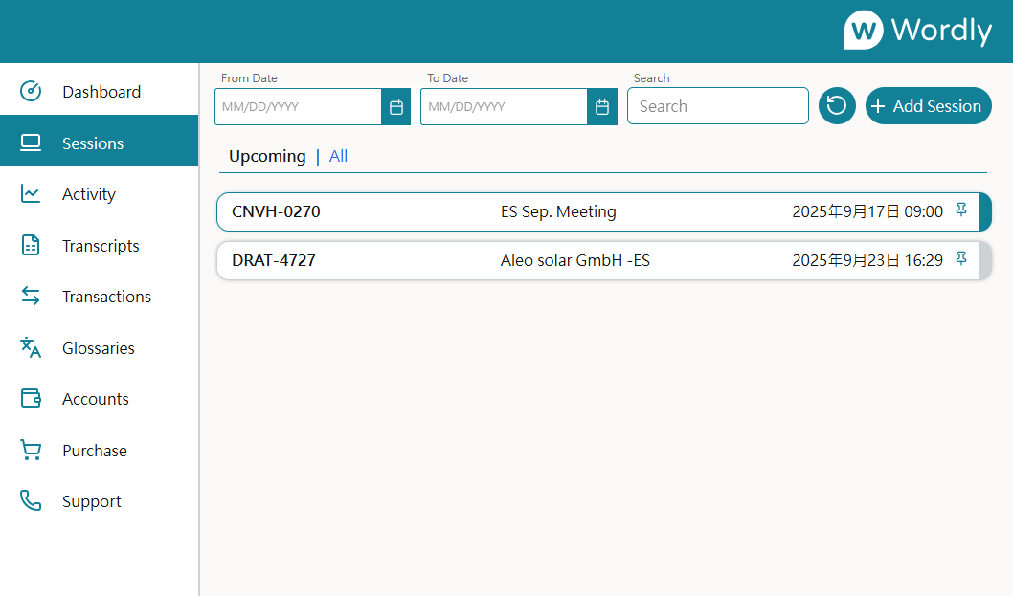
Step 3: Configure Session Details (see illustration below)
You will see a settings form; the items highlighted in yellow are the ones you need to fill in :
- Title : Session Name ( Primarily in English)
  - Applicant's colleague's name_ Teams Meeting topic.
  - Example: Zoe_Evershine Monthly Meeting
- Start date, Start time, Duration : Set the expected start date and time for this session.
- Pin : Pin this session to the screen.
- Language (Main Language of the Conference): Only one language can be selected.
- Selections ( Must include all speakers' languages) :
  - Choose the language the speaker will use from the drop-down menu . (Maximum 8 languages)
  - Example: Chinese (Mandarin) + English (US) + Japanese
- Attention!! Auto Select (highlighted in red ) must be enabled ! (This allows AI to automatically change the input language. )
- After completing the settings, please remember to click "Save" to save your configuration!

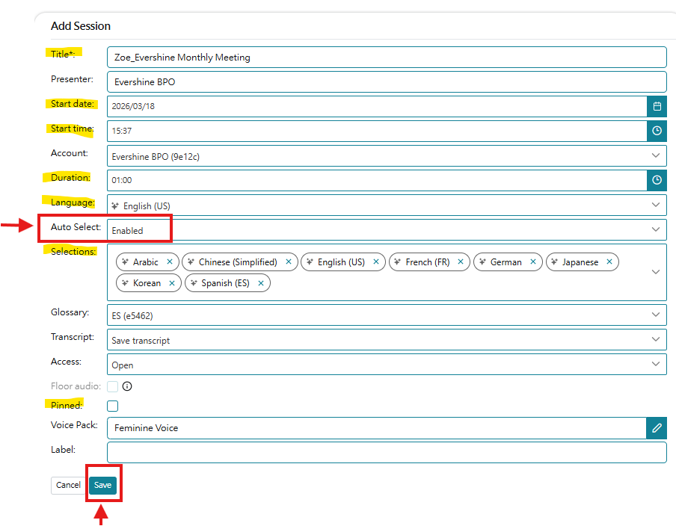
Step 4: Obtain Wordly Attendee Links
- a session is successfully established, the system will generate a unique QR code and an attendee-specific link. Note: This link number will be the same as the Session ID.
- Copy this link and send it to the participants . You can share it via email or in the Teams meeting chat room before the meeting starts.
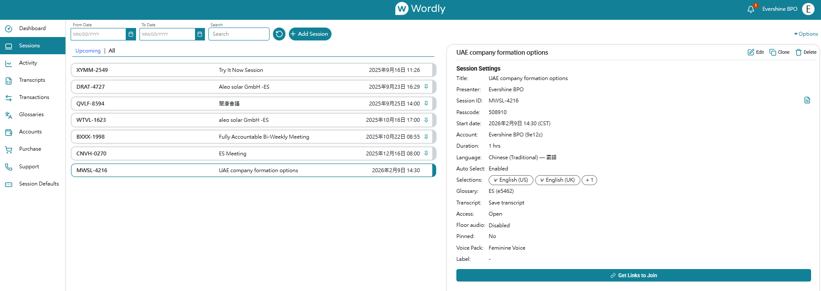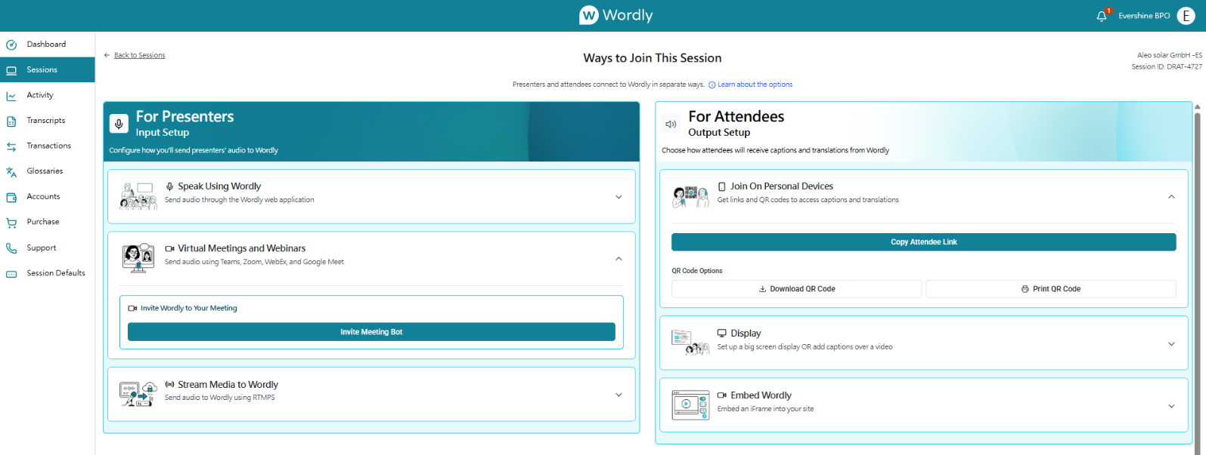
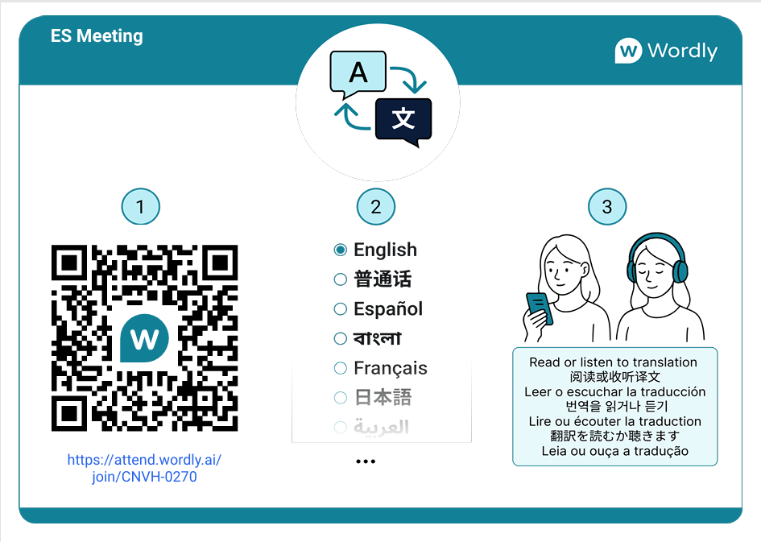
C. 15 minutes before the meeting starts : Start Wordly Translation
Step 1: The host joins the Teams meeting.
Step 2: Add Wordly Bot to the meeting
- On the page where you have created your session, find and click " Invite ". The " Meeting Boot " button :
Location: Panel > Session > Get Links to Join > For Presenters: Virtual Meetings and Webinars > Invite Meeting Boot​​
- Please paste your meeting link in the box below the Meeting Link (it must include https:// ) . Example:
https://teams.microsoft.com/meet/41885380422784?p=TCjL4BBKjWHg2ejcej
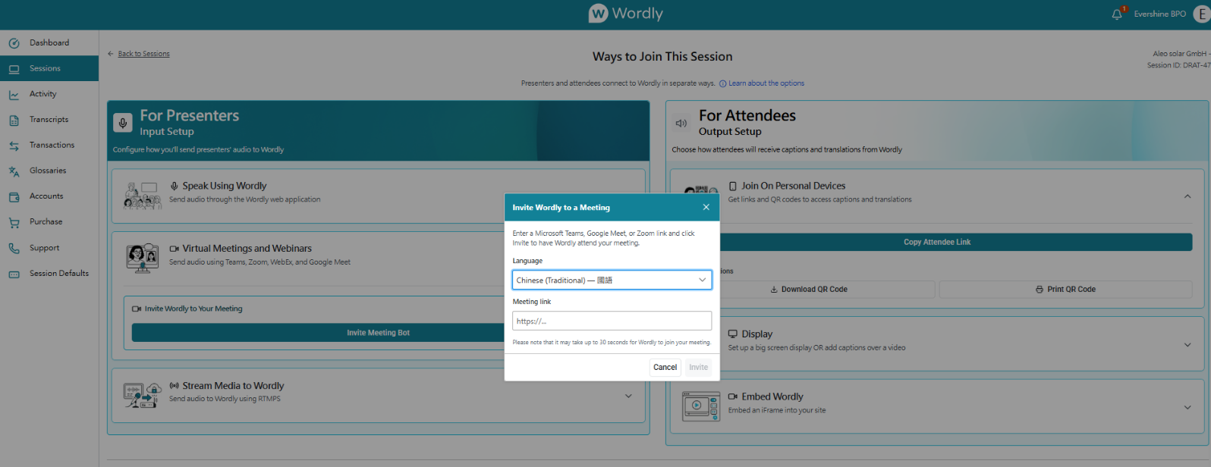
- Please ask the host to allow it to join the meeting . The Wordly Bot (usually named "Wordly") will automatically join your Teams meeting and will appear in the participant list like a participant.
  - Important Note: Wordly Bot requires clear meeting audio to translate. Please ensure your microphone is working properly.
Step 3: Inform attendees to use a translator.
- In the Teams meeting chat room, repost the previously copied Wordly Attendee Link .
- The following simple instructions can be used to guide participants in the operation:
"Hello everyone, this conference offers real-time translation services. Colleagues who require translation, please click the link below and select your desired language. We recommend using a mobile phone or another device to access the link so you can view the conference video and translated subtitles simultaneously."
[Please post your Most Attendee Link here]
Step 4: Start the meeting
- Once you've successfully joined the Wordly Bot and shared your participation link, you can officially begin your meeting. All speakers' voices will be translated in real-time.

D. At the end of the meeting: End the Wordly Session
Step 1: End the Teams meeting
- When your Teams meeting officially ends, please end the meeting as usual. Wordly Bot will automatically leave when the meeting ends.
Step 2: Manually end the Wordly Session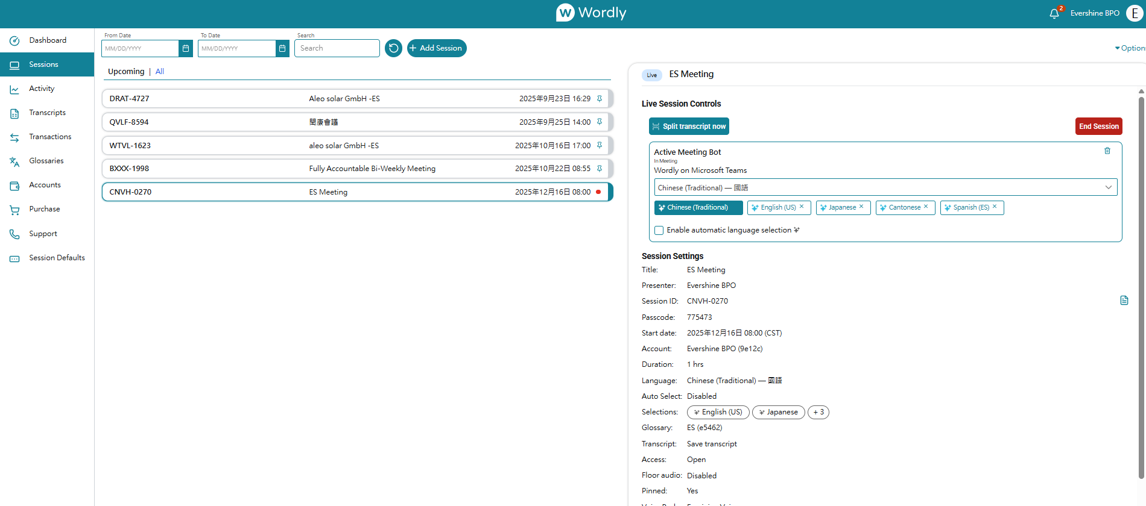
- To ensure correct billing and resource usage, please return to your Wordly operations page.
- Find the ongoing session and tap it. End Session​ Leave the translation session. This translation session will then stop being charged .
Step 3: (Optional) Download the verbatim translation.
- After a session ends, Wordly usually provides a transcript of the translation. You can find and download it from the session history if needed .

Please contact Qiu Liting at zoechiu@evershinecpa.com for inquiries about how to use it.
Please ask Zoe Chiu (邱莉婷) by email zoechiu@evershinecpa.com to obtain Yonghui's account (Email) and password so that you can log in to wordly.ai.

